SEND SWAP PARTNER REQUEST TO SALE SUPERUSER/HIGH AUTHORITY

STEP 1:

* Select the partners to swap

* Single partner can be selected for sending swap request or in bulk

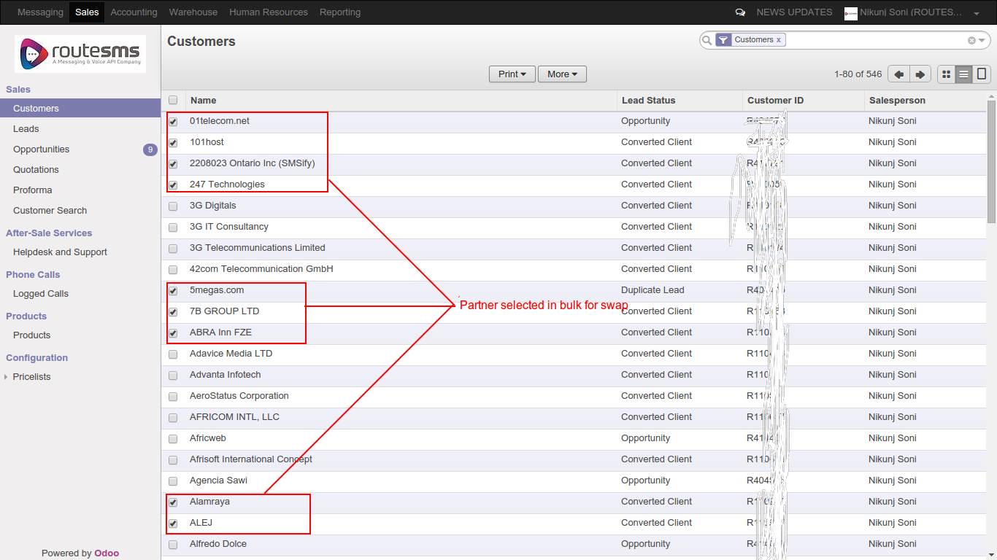

STEP 2:

* Click on “send swap partner request” from “More” option list

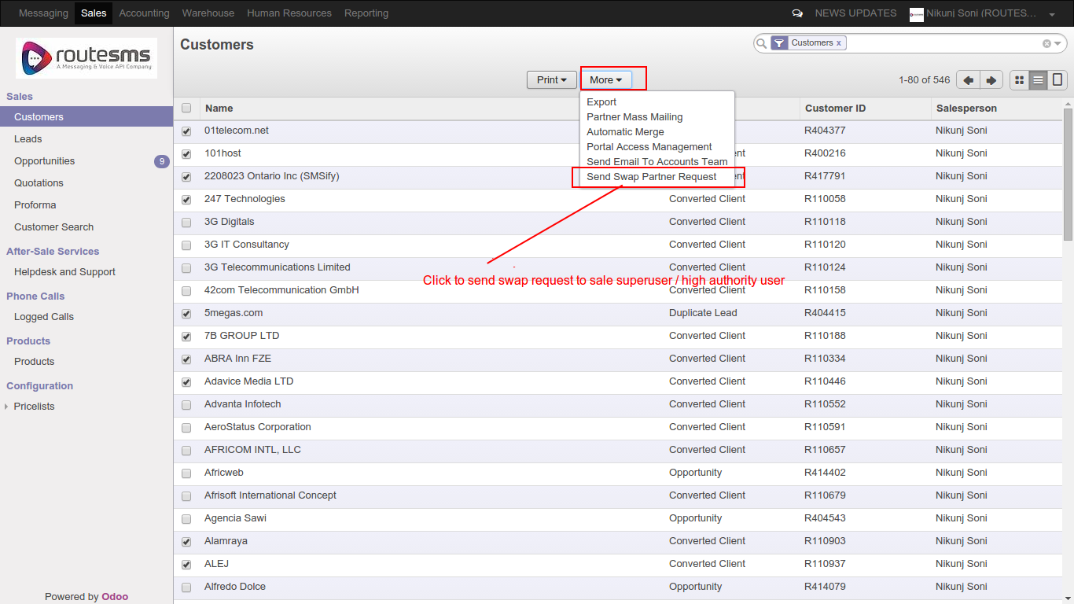

STEP 3:

* Select new BM

* Select Sale superuser.
Sale superuser is a saleperson who has the authority to send swap partner request to accounts team

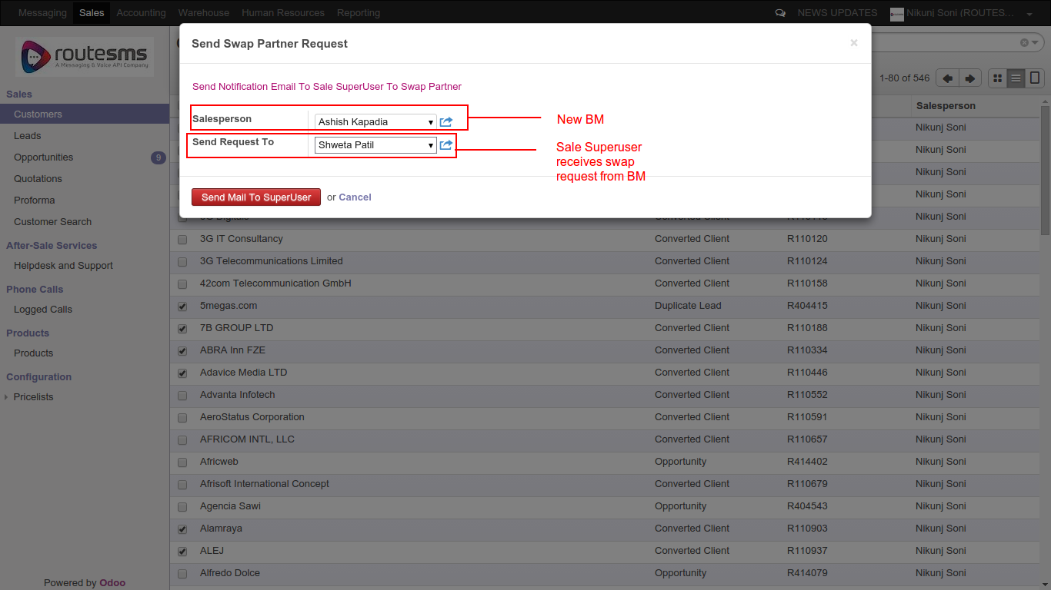

STEP 4 (For Sale Superuser only):

* Sale superuser will receiveemail notification along with excel sheet holding swap partner details like partner name,odoo id,old BM,new BM

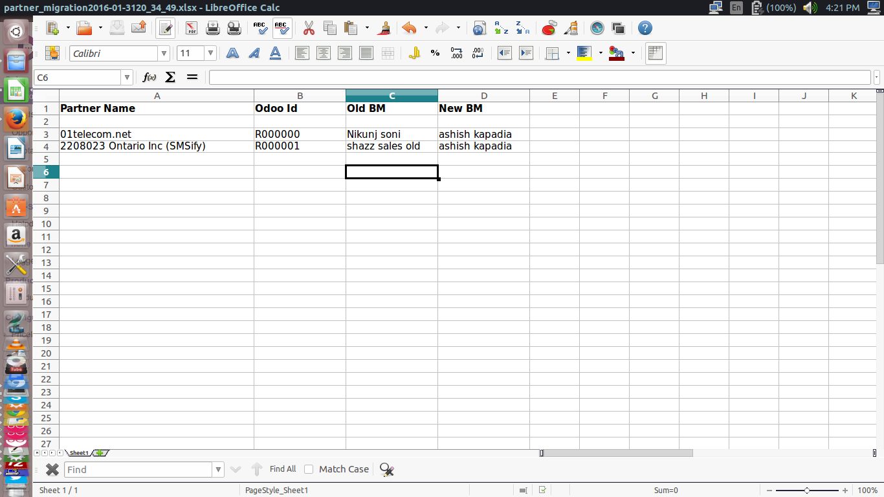

PARTNER SWAP FLOWCHART

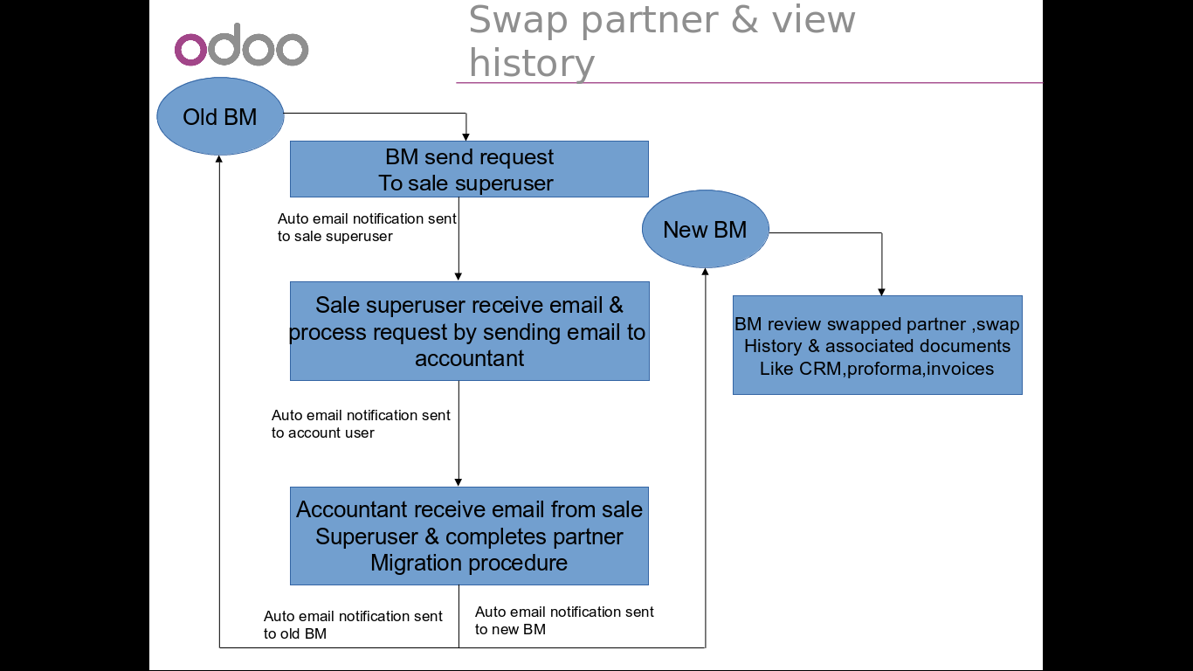

THANK YOU

Email: shashank.verma@bistacloud.com

Skype : bista_shashank

Ext: 684

